**CHAPTER 6**

**PROJECT DESCRIPTION**

This paper describes how to deploy and stream desktop applications for college management by using Amazon AppStream 2.0, a fully managed, secure application streaming service that runs in the AWS Cloud.

**6.1 OVERVIEW OF THE PROJECT**

* Developing a Desktop application of college management and sharing to a web application and deploy into aws cloud.
* The desktop applications can be stored and it can be shared to the browser. This applications will be saved in the server. The assurance of secure usage of applications cannot be given in this system.
* The data’s will be more securely shared to browser without any server problems or any other storing problems.
* The shared applications, data’s can be secured in VPC services and will be available 24/7.
* Provision an Amazon virtual private cloud (Amazon VPC) to provide an isolated virtual network infrastructure within the AWS Cloud. This AppStream 2.0 resources will use this environment.

**6.2 MODULE DESCRIPTION**

**6.2.1 Creating Network Resources and AppStream image builder**

Here you will create an Amazon virtual private cloud (VPC) and other network resources needed for your Appstream 2.0 environment. The following steps are used to create template in AWS cloud formation automatically and configure the necessary network resources.

* Sign into the AWS management console
* In the following list of regional choices, select and open the link associated with AWS region in which you want to build the Appstream 2.0 environment.
* In the menu upper right corner of the console, select the AWS region for our environment and currently AWS hosts 18 different region for our environment



* Select one of the seven region in which resources is available:

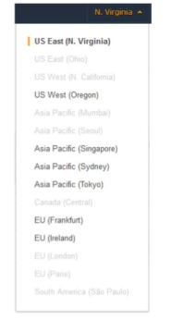

In the bottom right corner of the screen select **create,** so that it starts creating resources and display a status message to indicating the progress.

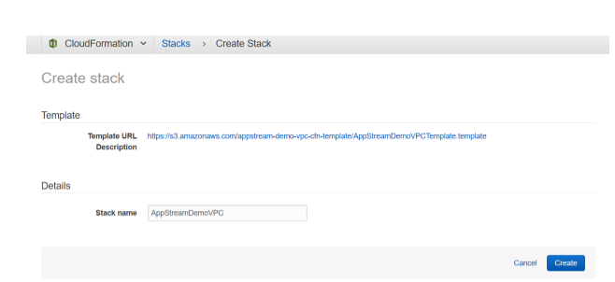

* After successful creation then navigate to the Amazon VPC console https://console .aws.amazon.com/vpc/.
* In the navigation pane, under virtual private cloud, choose your VPC

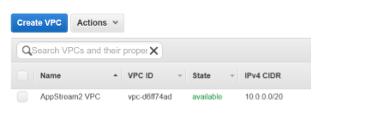

Under VPC choose **subnets,** and list of subnets you will see the following subnets that were automatically created.

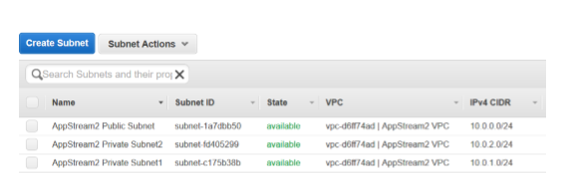

1. You have successfully created the network resources by using AWS cloud formation

**CREATING AN APPSTREAM 2.0 IMAGE BUILDER**

1. For streaming applications, AppStream 2.0 uses EC2 instances. You launch instances that AppStream 2.0 provides from base images, called image builders.
2. You connect to an image builder instance to create your own custom image, install and configure your streaming applications, and then create your image by creating an image builder instance snapshot.
3. To install and configure application to stream to users, you must create an image builder instance.

Deploy an image builder instance to install applications,

1. Open the appstream 2.0 console at <http://console.aws.amazon.com/appstream2>.
2. The navigation page appear like 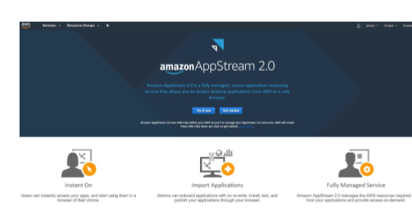

* In lower right corner of page, choose skip

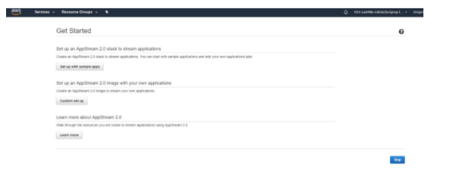

* In navigation pane choose images, image builder, launch image builder, and choose image window and select the Image builder with name Base-image-Builder-mm-dd-yyyy,where mm-dd-yyyy represents the recent date

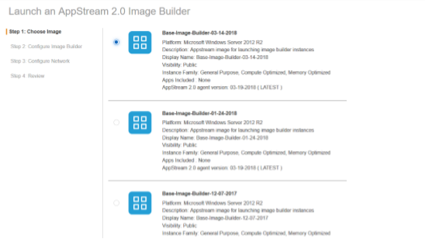

* Then click next, then configure image builder.

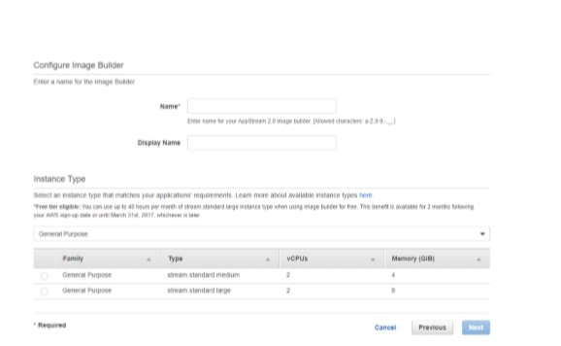

* Then choose **review** and confirm the details for image builder. If any change in the configuration choose **edit** and make any changes, once finished **launch** the resources, if any error message notifies then look for AWS service limits.

**6.2.2 CONNECT TO THE IMAGE BUILDER AND INSTALL APPLICATIONS**

To install and configure the applications to stream to users we must establish a remote connection to instance and configure the applications.

CONNECT TO IMAGE BUILDER INSTANCE:

* Open the Appstream2.0 console at <http://console,aws.amazon.com/appstream2>.
* In the navigation pane choose **images, image builder** and select image builder instance that created earlier and gain verify that status is **running** and choose connect.
* The new browser tap opens and displays option for logging into image builder instance, choose **local user, administrator**

**Download application installation files to your image builder instance**

* Google chrome browser for institution: http://institution.google.com/chrome/chrome-browser/
* College management:https://college-plus-plus.org/
* Launch Mozilla Firefox icon on the image builder instance desktop. If they are prompted by Firefox then choose **don’t import anything, NEXT.**
* Sign to Firefox and set a default browser, choose **USE FIREFOX AS MY DEFAULT BROWSER**
* Open Firefox and navigate to download chrome: <http://institution.google.com/chrome/chrome-browser/>.
* Download the chrome MSI for windows 64-bit and using Firefox navigate URL to download the institution installer:

<https://institution-plus-plus.org/>.

* Open the download link and download 64-bit*64
* Download institution installer and save file and then close tabs.
* Install the applications and run the applications and click finish to complete the installation.

**6.2.** **USE IMAGE ASSISTANT TO CREATE AN APPSTREAM 2.0 IMAGE**

* Create an application catalog using image assistant
* Test the app by using local user account which as same permission that end user will have in their streaming sessions.
* Optimize the application lunch performance and configure the image an later finish creating the image

CREATING APPSTREAM 2.0 APPLICATION CATALOG:

* Open image assistant, In the **ADD APPLICATION TO IMAGE** dialog box ADD APPS tabs then choose **ADD APPLICATION**
* Select the chrome.exe file and then choose **OPEN and SAVE** the file

**TEST APPLICATION BY USING LICAL USER ACCOUNT:**

1. In the test tab choose **switch user, Test user**
2. Open image assistant. In TEST application, the two application added are displayed.
3. Choose the first application and chrome to open it.After chrome has opened and loads the Amazon Web Services website, close the browser.
4. In the Test Applications window open the second application institution. When it gets opened and starts completely close the application.
5. Choose Switch user .On the Local User tab, choose Administartor.On the image assistant Test tab and choose next.

**Configure the image:**

On the configure image tab type the required information and image details should display as follows and choose next

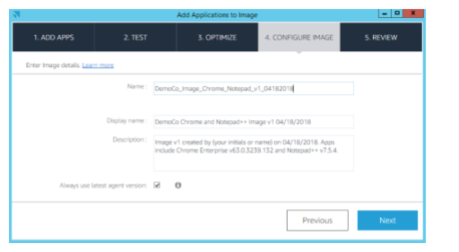

**Finish creating the image:**

* Look the image details and choose Disconnect and create image.
* The remote session disconnects within few moments, when the lost connectivity message appears close tab.
* Return to the Amazon Appstream 2.0 console and choose images, image registry. After image is been created, the image status appears Pending. Once the image is created, you cannot connect to it.
* Click refresh to update the status and image status takes about 20 mins, when image is created, the status changes to Available and the image builder is automatically stopped.

**6.3 PROVISION A FLEET**

* Provide details for fleet: open console and choose fleets and create fleet
* Choose an image: choose an image and choose next.

**Configure the fleet:**

* Choose instance type to define hardware configuration for each instance that makes fleets
* Under fleet type details, choose the fleet type that suits your fleet and also you can select either of the following like Always-on, On-Demand.
* Under User Session details ,define the maximum amount of time that users can connected to stream the session and choose 8 hours for Maximum session duration and choose 15 minutes for disconnect timeout.
* Select fleet capacity and set Minimum capacity to 2 and maximum capacity to 4 and click next.

**CONFIGURE THE NETWORK:**

* Configure network and select Default internet access .For VPC select **vpc-xxxxxxxx | (10.0.1.0/24)**. This is appstream2 private subnet1.
* For subnet 2, choose **subnet-xxxxxxxx | (10.0.1.0/24)**. This is appstream2 private subnet2. And choose Next
* After finishing reviewing the configuration details, choose **Create,** While the fleet is being created and fleet instances are provisioned, the status of your fleet displays as **Starting** in fleets list, Choose **Refresh** icon to update the fleet status until the status is **Running**
* After the status changes to **Running,** the fleets is available and create a stack.

**6.4 CREATE AN APPSTREA 2.0 STACK AND A STREAMING URL**

1. Provide detail for stack and associate your stack with a fleet

* Open the AppStream 2.0 console choose Stacks, create stack.

1. Enable persistent storage for the stack

* **Enable storage** and make sure **Enable home folders** is selected
* Choose **review** and choose create. After few moment the stack list reappears and stack status is **active**

1. Create a streaming URL

* In the navigation pane choose **stacks**
* For **stacks**, select the stack that is just created
* Choose **Actions, create streaming URL**
* In **create streaming url** dialog box type required information and choose **GET URL,** and copy link
* Enter the link and application catalog page dispalys and choose the chrome icon to stream and confirm

**6.5 TEST THE APPLICATION STREAMING EXPERIENCE:**

* Open first notification email and open Login Page link. Type the email address and choose set password
* The appsrtream2.0 application catalog page opens and chooseapplication to begin streaming.

**6.3 DATA FLOW DIAGRAM**

Data flow diagram is used to describe how the information is processed and stored and identifies how the information flows through the processes. Data flow diagram illustrates how the data is processed by a system in terms of inputs and outputs. The data flow diagram also depicts the flow of the process and it has various levels. The initial level is context level which describes the entire system functionality and the next level describes each and every sub module in the main system as a separate process or describes all the process involved in the system separately.

Data flow diagram are made up of number of symbols,

Square representing external entities, which are sources or destinations of data.

Circle representing processes, which take data as input, do something to it and output it.

Arrows representing the data flows, which can either, be electronic data or physical items.

Parallel lines representing data stores, including electronic stores such as databases or XML files and physical stores

**6.3.1 DFD Level 0:**

The users of college management are student and faculty.

The output of the system is reports. The users store and retrieve from the database

Login

College Management system

Database

Login

**Fig.6.1 DFD Level 0**

**6.3.2. DFD Level 1:**

In the DFD level 1, all information are been explained clearly. The user creates the forms and include various field that are required for college management system and given the database connections to each forms. The data’s are stored in the database. Next create the stack in the AWS console and then launch the image builder to develop the desktop application. Finally the results are deployed in the cloud environment

2.connections

Database

Forms

1.create 3.Create Stack

Stack in AWS

5. output

Image Builder

4. Launch builder

**Fig.6.2 DFD Level 1**

**6.4 ER DIAGRAM**

An entity–relationship model (ER model) describes inter-related things of interest in a specific domain of knowledge. An ER model is composed of entity types (which classify the things of interest) and specifies relationships that can exist between instances of those entity types. In software engineering an ER model is commonly formed to represent things that a business needs to remember in order to perform business processes. Consequently, the ER model becomes an abstract data model that defines a data or information structure that can be implemented in a database, typically a relational database.

Entity–relationship modeling was developed for database design by Peter Chen and published in a 1976 paper. Some ER modelers show super and subtype entities connected by generalization-specialization relationships, and an ER model can be used also in the specification of domain-specific ontology.

**6.4.1 College Management**

The ER Diagram for all the process flow is been given as follows. The Diagram is been given for all the processes such as the process flow is been specified.

WORKSHOP

Sports

Student

Attribute

Faculty

Subject code

Subject name

**Fig.6. Flow of college management**

**6.5 DATABASE DESIGN**

Database design is the process of producing a detailed data model of database. This data model contains all the needed logical and physical design choices and physical storage parameters needed to generate a design in a data definition language, which can then be used to create a database. A fully attributed data model contains detailed attributes for each entity.

The term database design can be used to describe many different parts of the design of an overall database system. Principally, and most correctly, it can be thought of as the logical design of the base data structures used to store the data. In the relational model these are the tables and views. In an object database the entities and relationships map directly to object classes and named relationships. However, the term database design could also be used to apply to the overall process of designing, not just the base data structures, but also the forms and queries used as part of the overall database application within the database management system (DBMS).

**TABLE 6.6.1 Student Form**

|  |  |  |
| --- | --- | --- |
| **S.NO** | **FIELD NAME** | **DATATYPE** |
| 1 | student name | Varchar |
| 2 | Student DOB | Date |
| 3 | Student Department | Varchar |
| 4 | Student Address | Varchar |
| 5 | Events | Varchar |

**TABLE 6.6.2 Faculty Form**

|  |  |  |
| --- | --- | --- |
| **S.NO** | **FIELD NAME** | **DATATYPE** |
| 1 | Faculty name | Varchar |
| 2 | Subject code | Number |
| 3 | Subject | Varchar |
| 4 | Department | Varchar |
| 5 | Address | Varchar |
| 6 | DOB | Date |

**6.6 INPUT DESIGN**

The input design is the link between the information system and the user. It comprises the developing specification and procedures for data preparation and those steps are necessary to put transaction data in to a usable form for processing can be achieved by inspecting the computer to read data from a written or printed document or it can occur by having people keying the data directly into the system. The design of input focuses on controlling the amount of input required, controlling the errors, avoiding delay, avoiding extra steps and keeping the process simple. The input is designed in such a way so that it provides security and ease of use with retaining the privacy. Input Design considered the following things:

* What data should be given as input?
* How the data should be arranged or coded?
* The dialog to guide the operating personnel in providing input.
* Methods for preparing input validations and steps to follow when error occur.

Input Design is the process of converting a user-oriented description of the input into a computer-based system. This design is important to avoid errors in the data input process and show the correct direction to the management for getting correct information from the computerized system.

It is achieved by creating user-friendly screens for the data entry to handle large volume of data. The goal of designing input is to make data entry easier and to be free from errors. The data entry screen is designed in such a way that all the data manipulates can be performed. It also provides record viewing facilities.

When the data is entered it will check for its validity. Data can be entered with the help of screens. Appropriate messages are provided as when needed so that the user will not be in maize of instant. Thus the objective of input design is to create an input layout that is easy to follow.

**6.7 OUTPUT DESIGN**

A quality output is one, which meets the requirements of the end user and presents the information clearly. In any system results of processing are communicated to the users and to other system through outputs. In output design it is determined how the information is to be displaced for immediate need and also the hard copy output. It is the most important and direct source information to the user. Efficient and intelligent output design improves the system’s relationship to help user decision-making.